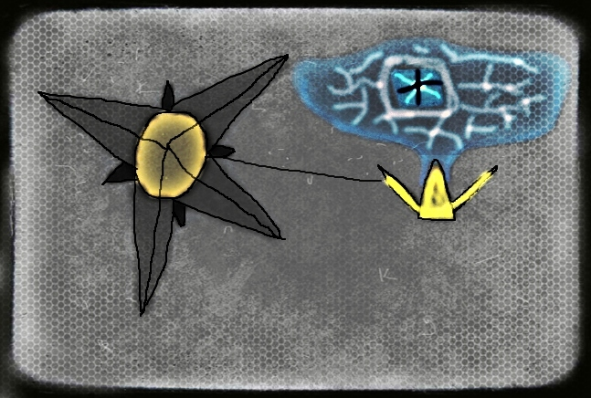

Description: File found on Collective Datapad showing discovered artifact and a gem surrounded by some sort of magnetic field within the compartment. Perhaps something the Collective hopes to use against the brotherhood?

